Home learning
Year 2
Date: 20.1.23
To be returned to school by Friday.

Reading – Please read your reading book a minimum of three times a week and ask an adult to write the book title and pages read in your reading record.

My spelling test score is : _______
Spelling – Please learn these words and spelling rule for a test on Friday.
can’t
didn’t
it’s
the boy’s
the girl’s
We have been learning an apostrophe for contraction this week. We know that we can use the apostrophe for a missing letter e.g. did not changes to didn’t.

We will be covering apostrophes for possession next week. An apostrophe then an s (‘s) identifies that the item belongs to that person e.g. the boy’s bag.
Maths – please complete the questions below.

1. | Complete the calculation  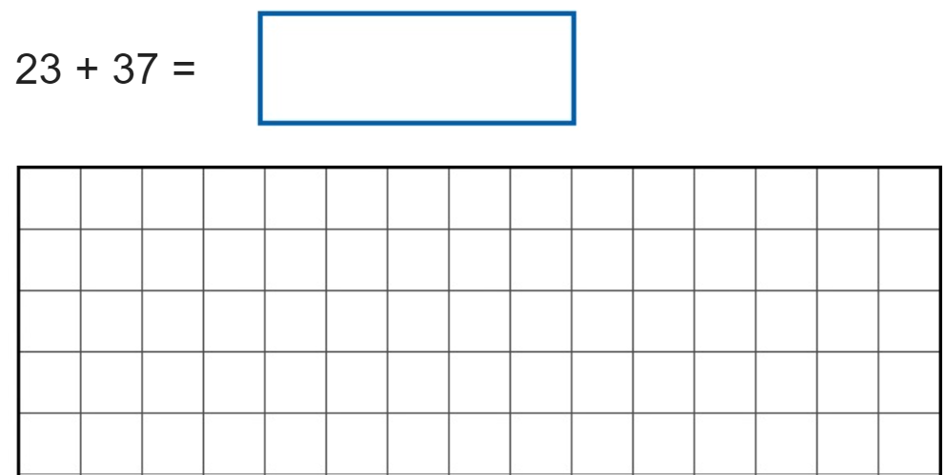 | 2. | Complete the calculations  86 – 29 =
3. | Name the 3D shapes  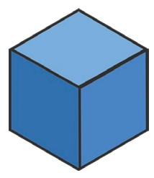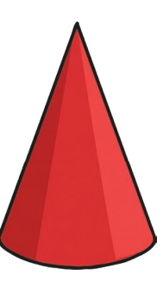  ________________ _______________ | 4. | What time is shown on the clock?  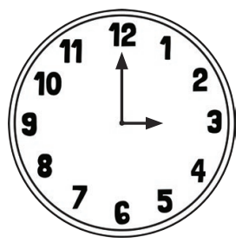  _______________________
5. | How much money is in the jar?  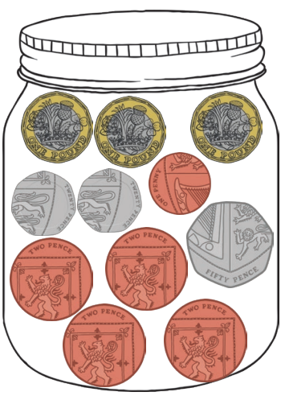 _______________________ | 6. | Complete the sequence  